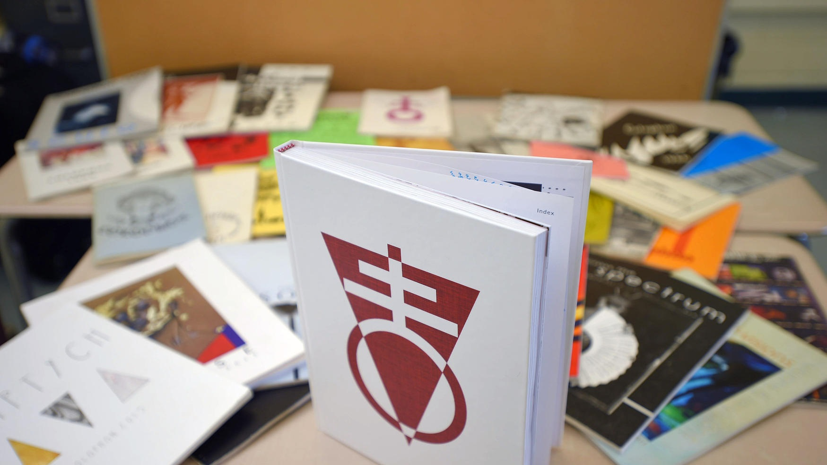  Colophon has been in continuous publication for more than 50 years.  Submissions to Colophon  Submissions can be made to the drop boxes in Rooms 221, 306 and 311 or (preferably) to the website: thscolophon.weebly.com.  Submissions to Colophon have few limitations other than you must be a current student of the school.  Otherwise, we are accepting all forms of visual art and writing, of most any length and size, on almost any theme or subject.  Please note though that we will use a multi-step evaluation process to determine that the works we do include are up to a standard of decency and quality that would complement the legacy we’ve established as a publication.  We will be in contact if a work of yours has been selected. |  |  | Who We Are  About Us  Colophon is Towson High School nationally recognized, award-winning student run literary and arts magazine.  Run as a club, Colophon’s student members solicit student created art and writing and each year evaluate and compile a best of into a carefully designed and professional printed magazine sold to the public and entered into national competition.  Colophon’s Website and Email  Website: thscolophon@weebly.com  Email: thscolophon@gmail.com  Advisor Contacts  Mr. Noah Belt – Art and Design | nbelt@bcps.org  Mr. Andrew Freeburger – Literature and Business | afreeburger@bcps.org  Mr. Nicholas Busselman – Literature and Business | nbusselman@bcps.org  Mr  Mr  Colophon  Towson High School  Thscolophon.weebly.com |  |  | 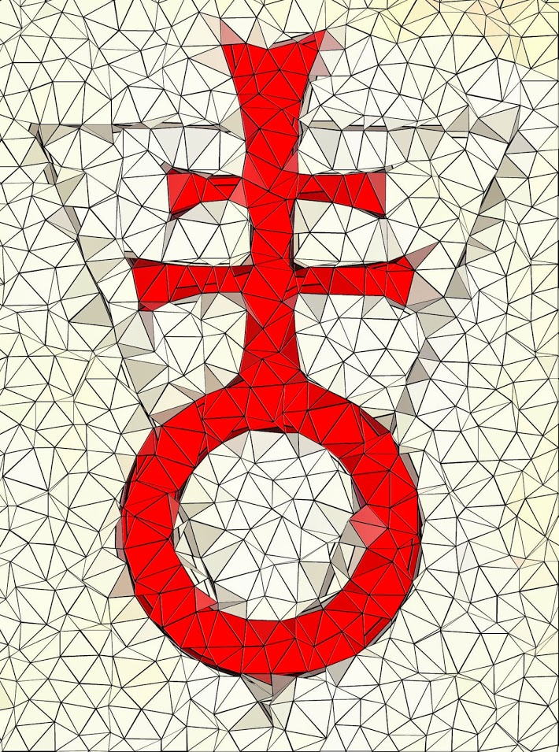  Colophon  - Towson High School’s Creative Arts Magazine

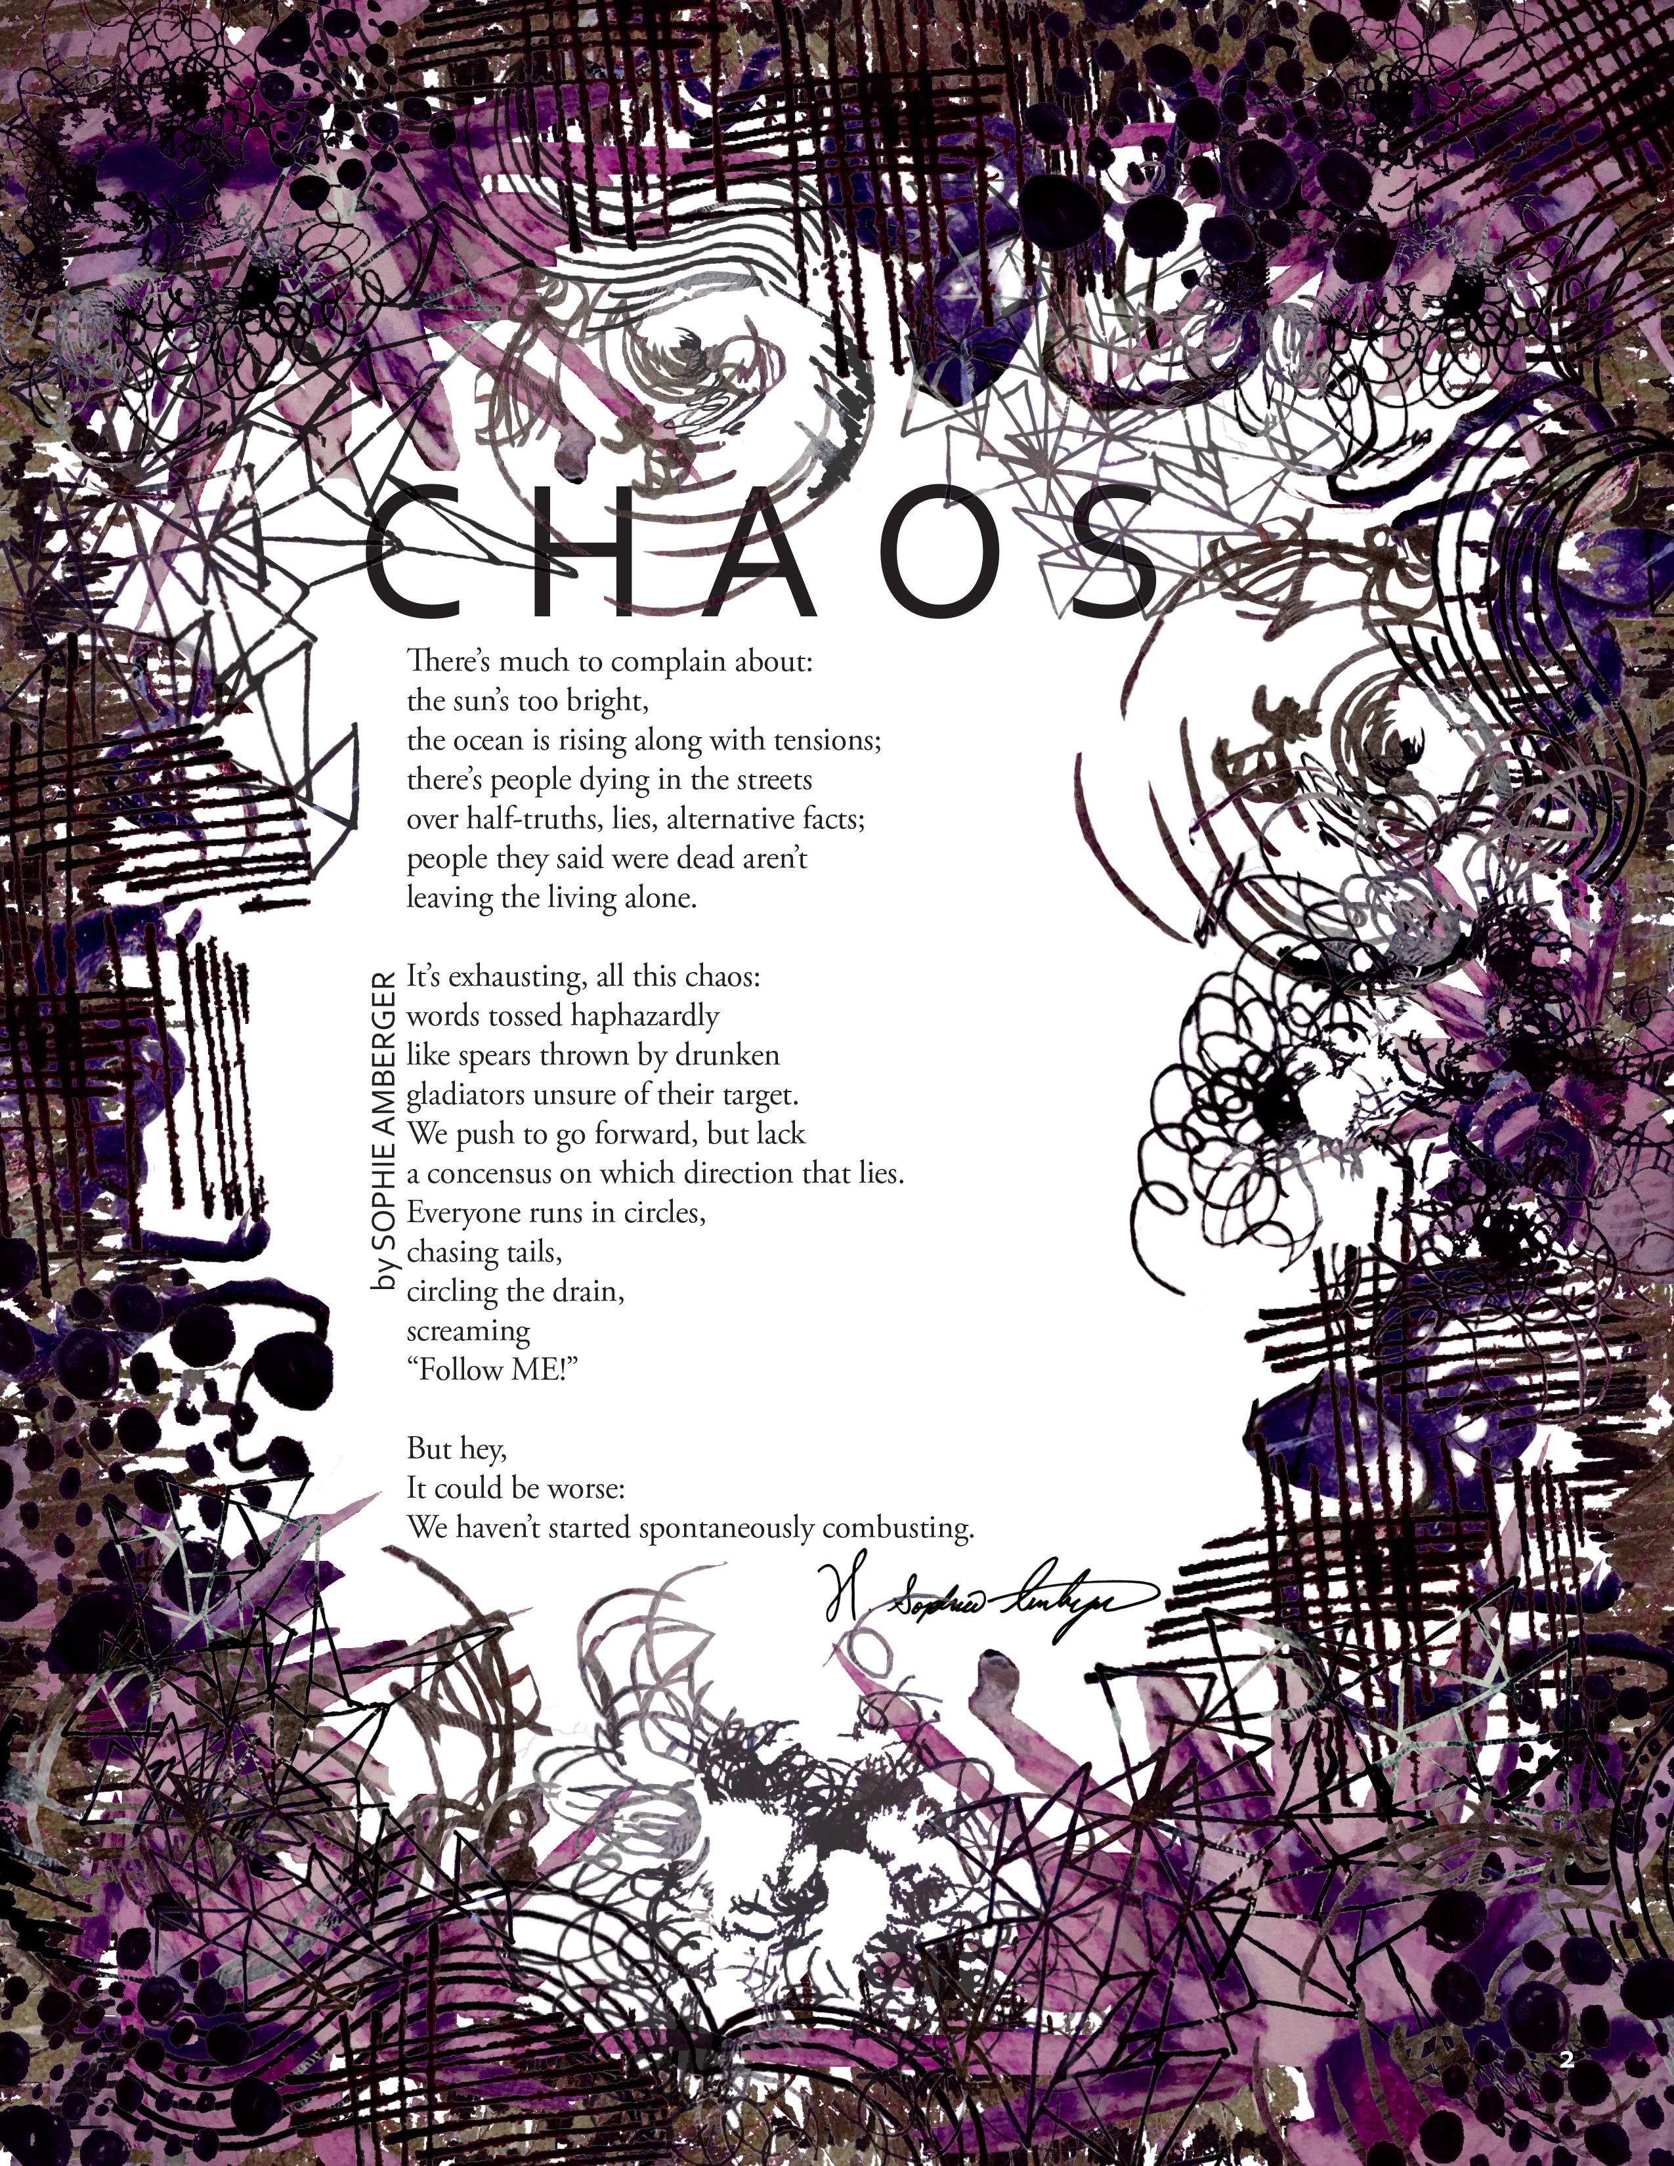  What is a year with Colophon like?  FALL  Encouraging submissions, fundraising, reading/evaluating literature, meeting monthly to discuss plans, communicating with club members regularly.  WINTER  Completing submissions/competitions and evaluations, seeking advertising, making selections for publication, evaluation of art submissions, begin designing magazine.  SPRING  Final design and publication of magazine, sales of books, entry into competitions, annual reading and art show (in May) |  |  | What does one do as a member of Colophon?  A lot! But more specifically, it depends on your interests and desires. Here are some of your options - and you can be a part of more than just one facet.  Art and Design  Students involved in this department of Colophon will be responsible for encouraging their peers to produce and submit art of all kinds. They will evaluate these works and decide which are worthy of inclusion of the magazine. They are also the design team for the magazine, working with editors and advisors to develop, organize and proof our magazine.  Literature  Students involved in the literary staff will be responsible for encouraging and submitting works of writing to the magazine. They will regularly fulfill reading and evaluation responsibilities, combing through our lit submissions to find the best of the best. Literary members are also invited to help in determining the vision and design of each year’s magazine.  Business and Communications  By default all members of Colophon are members of its business and communications team. Each member is expected to help in fundraising efforts, books sales and community outreach efforts. |  |  | By Grey Sheridan, 2017  All members of Colophon are encouraged to submit to the magazine themselves.  The Magazine  Each year we culminate our efforts by producing a professionally printed and bound magazine. This magazine is routinely among the nation’s finest and has developed a rich and distinguished presence in the annals of student publications.  The magazine, typically available in limited quantities during May and June each year. It is available for sale from Colophon members and advisors for a price of 10$.

